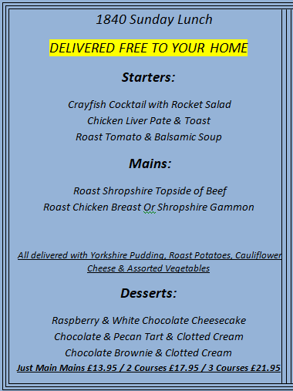
SUNDAY LUNCH DELIVERED TO YOUR HOME
EMAIL ORDER FORM TO food2share@outlook.com AND WE WILL CONTACT YOU TO CONFIRM ORDER & DELIVERY ASAP
Let us take the strain for you - We will bring you your Sunday Roast (meat / roasts/ stuffing / yorkies/ veg) enough for all of your guests, in an oven ready foiled tray – all cooked and ready to go–

Just needs popping in the oven to be reheated, warm up the gravy and you will be ready to go.

All delivered with Yorkshire Pudding, Roast Potatoes, Cauliflower Cheese & Assorted Vegetables
Why not make it a 2 or 3 course meal?
We can also deliver you the starters and desserts as part of the meal, to making your Sunday complete –
Name |  | Delivery Address Inc Postcode | (TF1 – TF8) | Contact Number |  | Delivery Date & Preferred Time Slot or Pick up (10% discount for pick up) |  | 1200-13:00
 |  |  |  |  |  |  |  | 13:00-14:00
 |  |  |  |  |  |  |  | 14:00-15:00
 |  |  |  |  |  |  |  | 15:00-16:00
Starters |  | QTY | Mains |  | QTY | Dessert | QTY
Crayfish Cocktail & Rocket salad |  |  | Roast Shropshire Gammon |  |  | Raspberry & White Chocolate Cheesecake
Chicken Liver Pate & Toast |  |  | Roast Shropshire Beef |  |  | Chocolate & Pecan Tart & Clotted Cream
Roast Tomato & Balsamic Soup |  |  | Roast Chicken Breast |  |  | Chocolate Brownie & Clotted Cream
Just Main Mains £13.95 / 2 Courses £17.95 / 3 Courses £21.95
RESTAURANT USE |  | Qty | Total | Confirmed Delivery Date | Confirmed Delivery Slot
1 course | £13.95
2 Course | £17.95
3 Course | £21.95
 |  | TOTAL

